Pythagorean Inequality
# Source: AI Source: Provided by: [Data Path: Persons Table -> ID Column: 1, Name_En Column: Motasem Essam] -> From: [ChatGPT] on [7/25/2026]
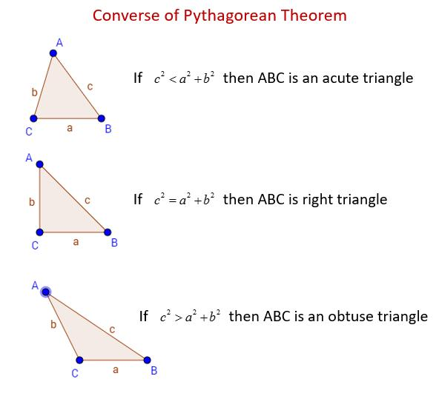
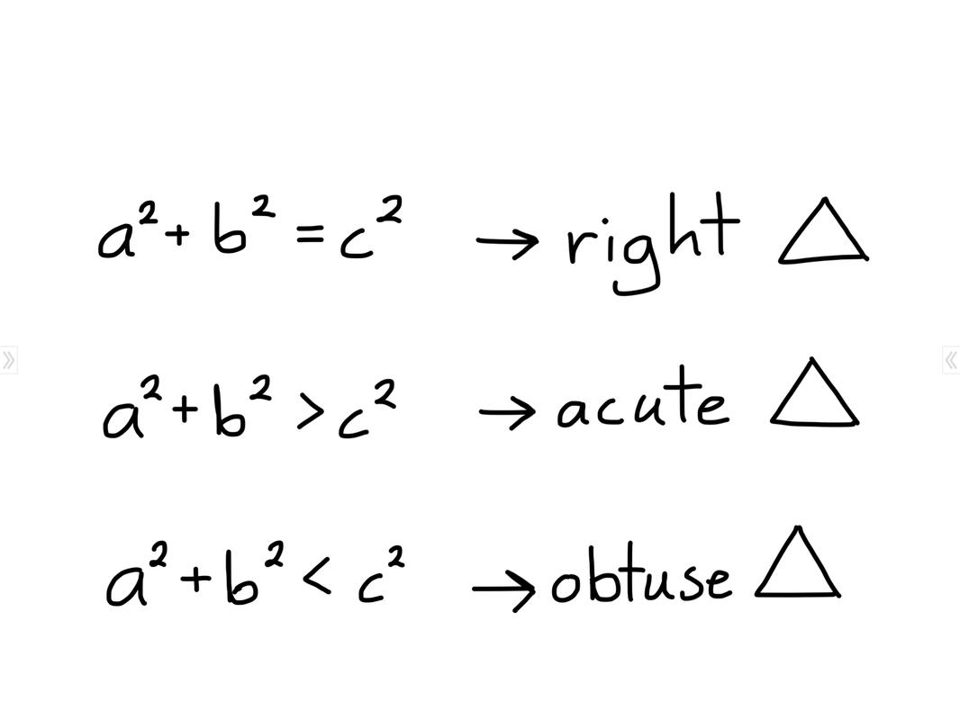
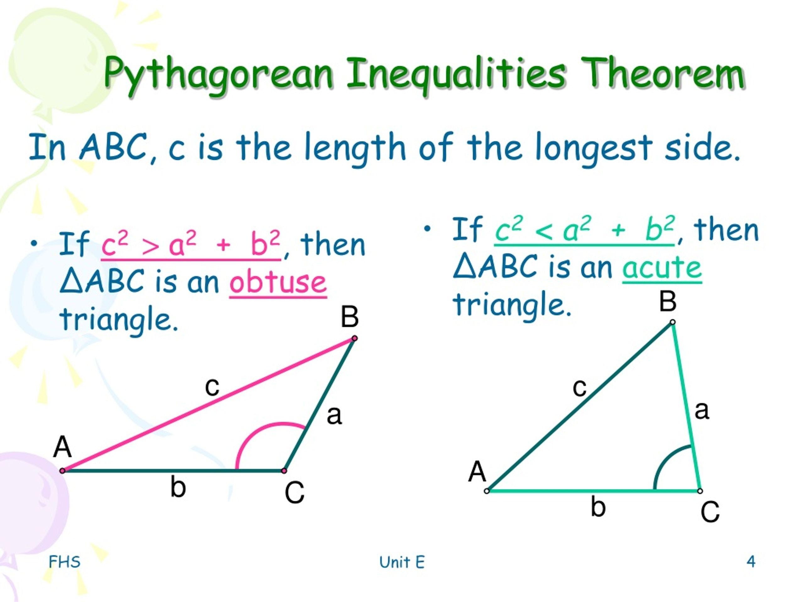

Definition
# Source: AI Source: Provided by: [Data Path: Persons Table -> ID Column: 1, Name_En Column: Motasem Essam] -> From: [ChatGPT] on [7/25/2026]
The Pythagorean Inequality is a set of inequalities that uses the side lengths of a triangle to determine whether the triangle is acute, right, or obtuse.
Let $c$be the longest side of a triangle, and let $a$and $b$be the other two sides.
The classification is:
$$\boxed{c^{2}<a^{2}+b^{2} ⇒ \text{Acute Triangle}} \\ \boxed{c^{2}=a^{2}+b^{2} ⇒ \text{Right Triangle}} \\ \boxed{c^{2}>a^{2}+b^{2} ⇒ \text{Obtuse Triangle}}$$
This is commonly called the Converse of the Pythagorean Theorem, or the Pythagorean Inequalities when considering the two strict inequalities.

Fundamental Concept
# Source: AI Source: Provided by: [Data Path: Persons Table -> ID Column: 1, Name_En Column: Motasem Essam] -> From: [ChatGPT] on [7/25/2026]
The ordinary Pythagorean theorem applies specifically to a right triangle:
$$\boxed{a^{2}+b^{2}=c^{2}}$$
The Pythagorean inequalities extend this comparison to all triangles.
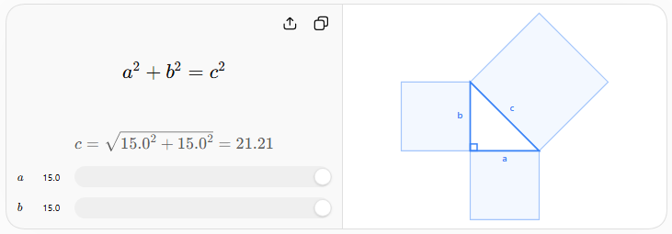
The key is to compare the square of the longest side $c$with the sum of the squares of the other two sides.
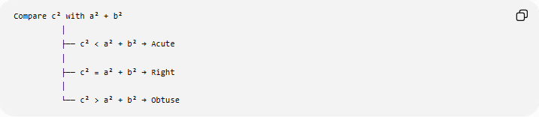
Compare c² with a² + b²
│
├── c² < a² + b² → Acute
│
├── c² = a² + b² → Right
│
└── c² > a² + b² → Obtuse

1. Acute Triangle
# Source: AI Source: Provided by: [Data Path: Persons Table -> ID Column: 1, Name_En Column: Motasem Essam] -> From: [ChatGPT] on [7/25/2026]
If:
$$\boxed{c^{2}<a^{2}+b^{2}}$$
then the triangle is acute.
All three angles are less than ${90}^{∘}$:
$$\boxed{∠A<{90}^{∘}, ∠B<{90}^{∘}, ∠C<{90}^{∘}}$$
Example
Sides:
$$3, 4, 5$$
would give:
$$5^{2}=25$$
and:
$$3^{2}+4^{2}=25.$$
So $3,4,5$is actually right, not acute.
For an acute example, use:
$$4, 5, 6.$$
The longest side is $6$:
$$6^{2}=36$$
while:
$$4^{2}+5^{2}=16+25=41.$$
Therefore:
$$\boxed{36<41}$$
so $4,5,6$forms an acute triangle.

2. Right Triangle
# Source: AI Source: Provided by: [Data Path: Persons Table -> ID Column: 1, Name_En Column: Motasem Essam] -> From: [ChatGPT] on [7/25/2026]
If:
$$\boxed{c^{2}=a^{2}+b^{2}}$$
then the triangle is right.
The angle opposite $c$is exactly:
$$\boxed{{90}^{∘}}$$
Example
For:
$$3, 4, 5 \\ 5^{2}=3^{2}+4^{2} \\ 25=9+16$$
Therefore:
$$\boxed{25=25}$$
and the triangle is right.

3. Obtuse Triangle
# Source: AI Source: Provided by: [Data Path: Persons Table -> ID Column: 1, Name_En Column: Motasem Essam] -> From: [ChatGPT] on [7/25/2026]
If:
$$\boxed{c^{2}>a^{2}+b^{2}}$$
then the triangle is obtuse.
The angle opposite the longest side $c$is greater than ${90}^{∘}$:
$$\boxed{{90}^{∘}<∠C<{180}^{∘}}$$
Example
Consider:
$$3, 4, 6.$$
The longest side is $6$:
$$6^{2}=36$$
and:
$$3^{2}+4^{2}=25.$$
Therefore:
$$\boxed{36>25}$$
so the triangle is obtuse.

Complete Classification
# Source: AI Source: Provided by: [Data Path: Persons Table -> ID Column: 1, Name_En Column: Motasem Essam] -> From: [ChatGPT] on [7/25/2026]
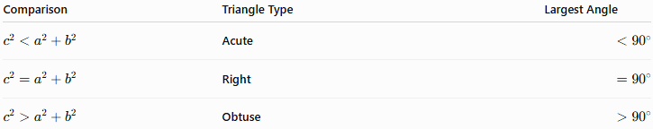
Comparison | Triangle Type | Largest Angle
$$c^{2}<a^{2}+b^{2}$$ | Acute | $$<{90}^{∘}$$
$$c^{2}=a^{2}+b^{2}$$ | Right | $$={90}^{∘}$$
$$c^{2}>a^{2}+b^{2}$$ | Obtuse | $$>{90}^{∘}$$
This relationship can be summarized as:
$$\boxed{\begin{matrix}c^{2}<a^{2}+b^{2}⇒\text{Acute} \\ c^{2}=a^{2}+b^{2}⇒\text{Right} \\ c^{2}>a^{2}+b^{2}⇒\text{Obtuse}\end{matrix}}$$

Why the Longest Side Is Used
# Source: AI Source: Provided by: [Data Path: Persons Table -> ID Column: 1, Name_En Column: Motasem Essam] -> From: [ChatGPT] on [7/25/2026]
The side $c$must be the longest side.
If:
$$a≤b≤c$$
then $c$is opposite the largest angle.
By the Law of Cosines:
$$c^{2}=a^{2}+b^{2}-2ab\cos{C}$$
where $C$is the angle opposite $c$.
Rearranging:
$$c^{2}-\left(a^{2}+b^{2}\right)=-2ab\cos{C}$$
Therefore, the sign of
$$c^{2}-\left(a^{2}+b^{2}\right)$$
depends on the sign of $\cos{C}$.
If $C<{90}^{∘}$
$$\cos{C}>0$$
so:
$$\boxed{c^{2}<a^{2}+b^{2}}$$
If $C={90}^{∘}$
$$\cos{C}=0$$
so:
$$\boxed{c^{2}=a^{2}+b^{2}}$$
If $C>{90}^{∘}$
$$\cos{C}<0$$
so:
$$\boxed{c^{2}>a^{2}+b^{2}}$$
This provides the mathematical basis for the Pythagorean inequalities.

Relationship to Triangle Classification
# Source: AI Source: Provided by: [Data Path: Persons Table -> ID Column: 1, Name_En Column: Motasem Essam] -> From: [ChatGPT] on [7/25/2026]
The Pythagorean inequality is primarily an angle-classification criterion based on side lengths.
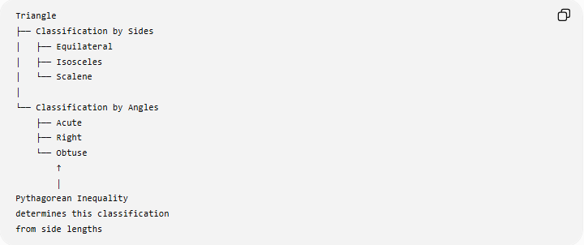
Triangle
├── Classification by Sides
│ ├── Equilateral
│ ├── Isosceles
│ └── Scalene
│
└── Classification by Angles
├── Acute
├── Right
└── Obtuse
↑
│
Pythagorean Inequality
determines this classification
from side lengths
For example, it can distinguish:
- Scalene Acute Triangle
- Scalene Right Triangle
- Scalene Obtuse Triangle
- Isosceles Acute Triangle
- Isosceles Right Triangle
- Isosceles Obtuse Triangle

Relationship to Pythagorean Theorem
# Source: AI Source: Provided by: [Data Path: Persons Table -> ID Column: 1, Name_En Column: Motasem Essam] -> From: [ChatGPT] on [7/25/2026]
The Pythagorean theorem is the equality case:
$$\boxed{a^{2}+b^{2}=c^{2}}$$
The Pythagorean inequalities are the two non-equality cases:
$$\boxed{a^{2}+b^{2}>c^{2}}$$
for an acute triangle, and
$$\boxed{a^{2}+b^{2}<c^{2}}$$
for an obtuse triangle.
So:
$$\boxed{\text{Pythagorean Theorem}=\text{Right-Triangle Equality}}$$
while:
$$\boxed{\text{Pythagorean Inequalities}=\text{Acute/Obtuse Cases}}$$

Important Requirement: Triangle Inequality
# Source: AI Source: Provided by: [Data Path: Persons Table -> ID Column: 1, Name_En Column: Motasem Essam] -> From: [ChatGPT] on [7/25/2026]
Before applying the Pythagorean inequality, the three lengths must actually be capable of forming a triangle.
They must satisfy:
$$\boxed{a+b>c}$$
when $c$is the longest side.
For example:
$$2, 3, 6$$
cannot form a triangle because:
$$2+3<6.$$
Therefore, it is incorrect to classify $2,3,6$as acute, right, or obtuse using the Pythagorean inequality.

Examples

Example 1 — Acute
# Source: AI Source: Provided by: [Data Path: Persons Table -> ID Column: 1, Name_En Column: Motasem Essam] -> From: [ChatGPT] on [7/25/2026]
$$a=5, b=6, c=7 \\ 7^{2}=49 \\ 5^{2}+6^{2}=61$$
Therefore:
$$\boxed{49<61}$$
Result: Acute triangle.

Example 2 — Right
# Source: AI Source: Provided by: [Data Path: Persons Table -> ID Column: 1, Name_En Column: Motasem Essam] -> From: [ChatGPT] on [7/25/2026]
$$a=5, b=12, c=13 \\ {13}^{2}=169 \\ 5^{2}+{12}^{2}=25+144=169$$
Therefore:
$$\boxed{169=169}$$
Result: Right triangle.

Example 3 — Obtuse
# Source: AI Source: Provided by: [Data Path: Persons Table -> ID Column: 1, Name_En Column: Motasem Essam] -> From: [ChatGPT] on [7/25/2026]
$$a=4, b=5, c=7 \\ 7^{2}=49 \\ 4^{2}+5^{2}=16+25=41$$
Therefore:
$$\boxed{49>41}$$
Result: Obtuse triangle.

Key Points
# Source: AI Source: Provided by: [Data Path: Persons Table -> ID Column: 1, Name_En Column: Motasem Essam] -> From: [ChatGPT] on [7/25/2026]
- The longest side must be identified first.
- Let the longest side be $c$.
- Compare $c^{2}$with $a^{2}+b^{2}$.
- If:
$$\boxed{c^{2}<a^{2}+b^{2}}$$
the triangle is acute.
- If:
$$\boxed{c^{2}=a^{2}+b^{2}}$$
the triangle is right.
- If:
$$\boxed{c^{2}>a^{2}+b^{2}}$$
the triangle is obtuse.
- The three lengths must first satisfy the triangle inequality.
- The method is based mathematically on the Law of Cosines.
- It is especially useful when the side lengths are known but the angles are not.

Conclusion
# Source: AI Source: Provided by: [Data Path: Persons Table -> ID Column: 1, Name_En Column: Motasem Essam] -> From: [ChatGPT] on [7/25/2026]
The Pythagorean Inequality provides a direct way to classify a triangle as acute, right, or obtuse using only its side lengths. With $c$as the longest side, the comparison between $c^{2}$and $a^{2}+b^{2}$completely determines the type of the largest angle:
$$\boxed{\begin{matrix}c^{2}<a^{2}+b^{2} & ⇒ & \text{Acute} \\ c^{2}=a^{2}+b^{2} & ⇒ & \text{Right} \\ c^{2}>a^{2}+b^{2} & ⇒ & \text{Obtuse}\end{matrix}}$$

